Paper 4 Topic Proposal

Topic:

The rates of suicide have been increasing throughout the years and although there are multiple reasons as to why one might become suicidal especially teens, we must take a look into social media and the negative effects it can cause to young teens. We have begun living in a world where we can’t differ reality from a fantasy and thus makes many more prone to feeling worthless, diagnosed with depression or anxiety, or even be cyberbullied.

Cause:

Cyberbullying- Before technology, there was no need for parents to worry about cyberbullying but times are changing and children these days are growing up with technology. Younger children are more prone to the negative things that technology has to offer, they have not fully understood the grasp of technology and how it can be manipulated. According to the *Megan Meier Foundation,* about 34% of students experience cyberbullying during their lifetime and 59% of U.S teens have been bullied or harassed online.

Mental Health Issues- We see that the rise in anxiety is increasing yearly in teens. This might be because schools have become pressure cookers or expect so much more than students can give. This is why students arriving at college often seek guidance and therapy for the help they need. It is clear that there is a correlation between the number of teens who have been diagnosed with some sort of mental illness and the risk of suicide. Why are students reporting more anxiety and depression in recent years especially in younger generations? Does it have to do with school, society, or home? C.A.M also dives into this question and found that in recent years the rate of anxiety and depression have skyrocketed and thus the need for many students to feel the need to be protected.

Unrealistic Social Comparison – As we read in C.A.M more and more girls are falling prey to the “idolized” body. Many often seek the approval of society and feel as though they might never reach “perfection.” Girls are more prone to the negative effects of social media since they spend more time in school and they often get suck into the life of others. What these girls don’t realize is that this life that most people live is not real. We see the issue at hand today, with companies needing to photoshop everything and everyone to please society and their standards. Social media is the link to depression and anxiety or even cyberbullying that often later leads to suicide.

As C.A.M has stated more girls are prone to suicidal thoughts for many factors, but young boys have the highest percent of suicided. This is because when a young girl attempts suicide, they usually don’t attempt something that will ensure that they are successful whereas boys are most likely to use a gun or something that guarantees the suicide to be successful.

Unless we find the root for suicide we won’t be able to help young children keep these thoughts away and lower the percentage of suicide rates.

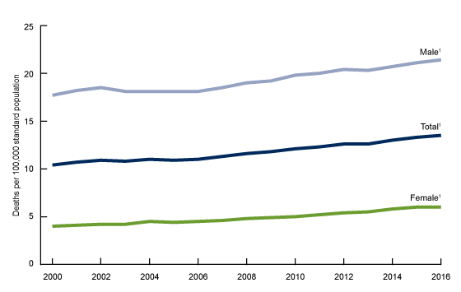According to the CDC: <https://www.cdc.gov/nchs/products/databriefs/db309.htm>

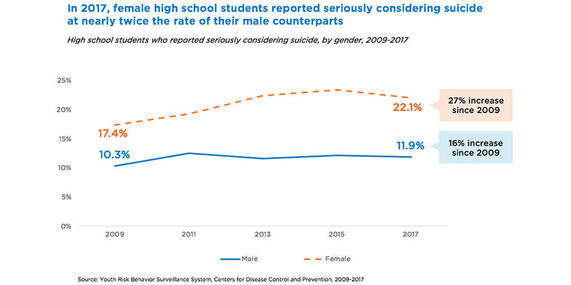

<https://www.childtrends.org/blog/high-school-aged-youth-considering-and-committing-suicide-among-female-students>